# Buying MGV Tokens

VIDEO

Buying MGV tokens is easy! Here’s how to do it:

1. Go to PancakeSwap and add the contract address to add MGV as an option. Tick the I understand option and click on Import.

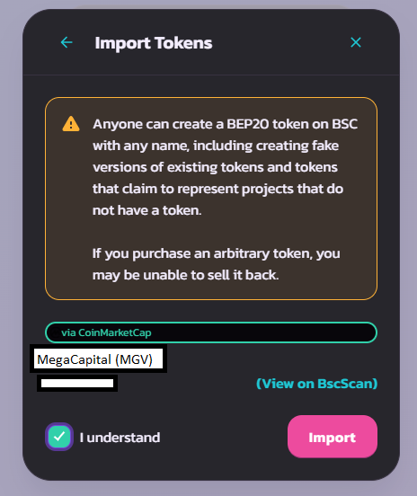

2. You should now have the option to swap a cryptocurrency to a MGV token.

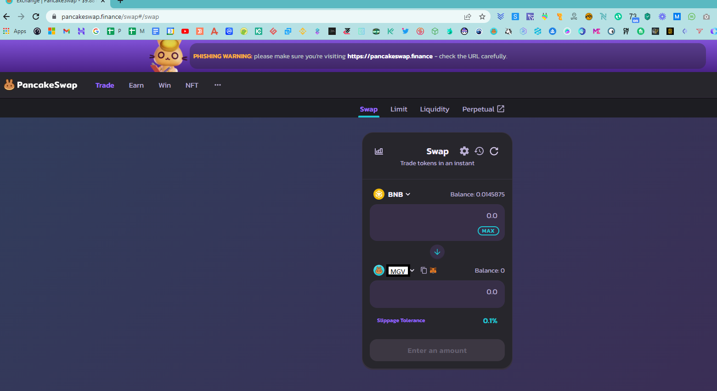

3. Connect your MetaMask wallet.

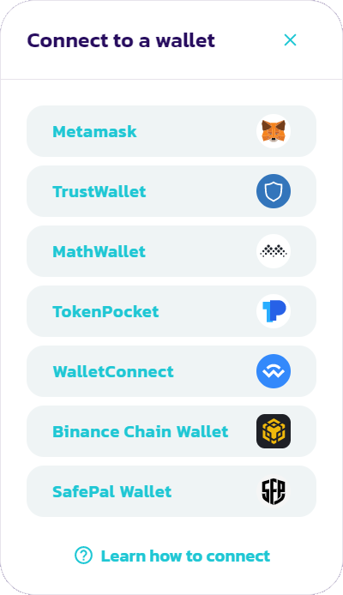

4. Unlock your MetaMask wallet if prompted.

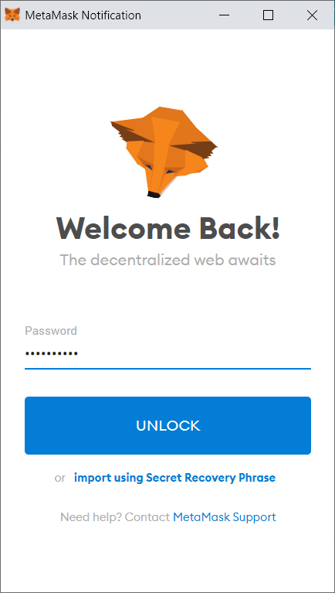

5. You are now connected to your wallet and can see your token balance. Choose which token from your assets and how much of it you want to swap for the MGV token and click on Swap.

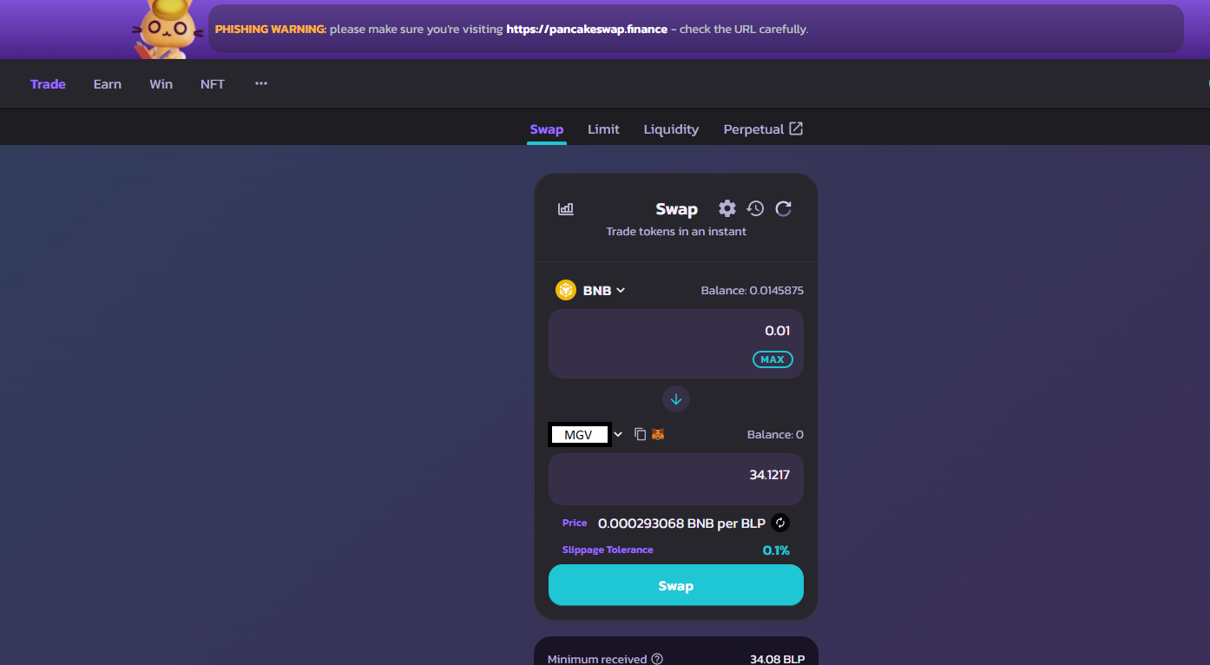

6. A window will pop-up showing you the estimated sum you will receive and asking you to confirm your swap. Click on Confirm Swap.

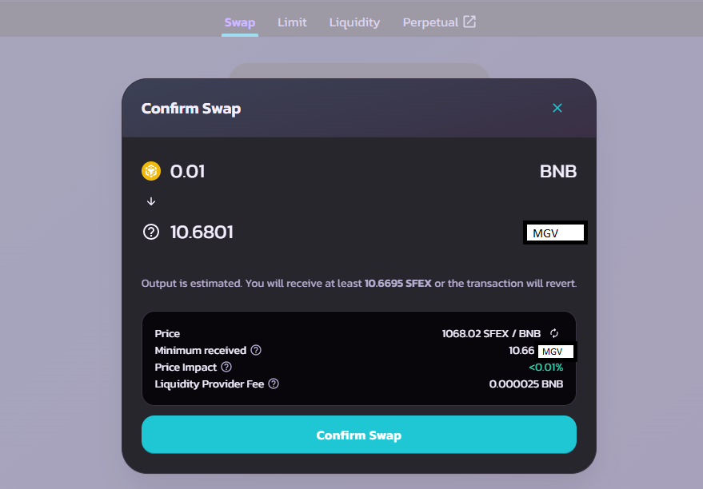

7. Next, MetaMask will ask you to confirm swapping one token for another. Click on Confirm.

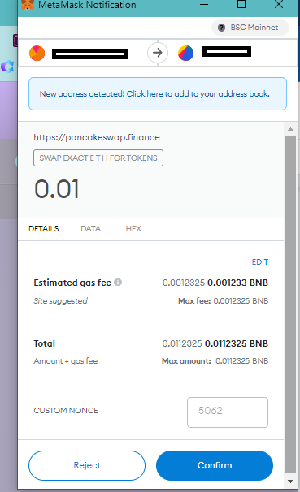

8. Once the transaction is submitted, PancakeSwap will offer you to view your transaction and add MGV to MetaMask.

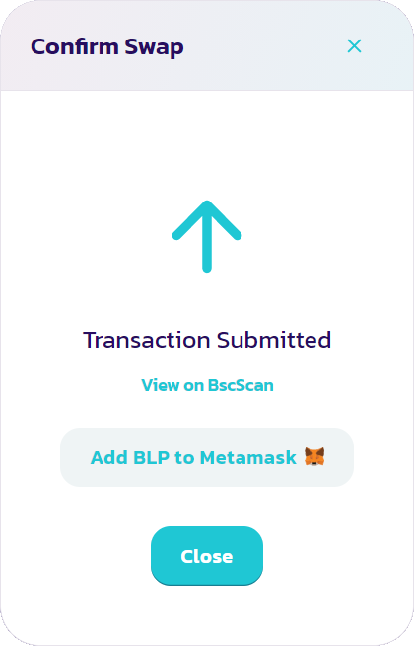

9. Your MGV tokens will now be seen in your MetaMask wallet.